Nickels for Knights
Thank you so much for your prior support to the Airdrie 1st Club Hamper Program. All your donations have helped them to make the Holiday Season better for their families in need. They anticipate that this year’s needs will be greater than ever.
We are asking students to bring spare change (Nickels, Dimes, Quarters, Loonies and Toonies) to the office OR use School Cash Online to donate either $ 1 - $ 2 - $5 - $ 10 OR $ 20. This is completely voluntary. It is an opportunity for students to learn the joy of giving and charity.
This campaign will start November 1st and go on to November 30th. The gift cards will be presented to the Airdrie 1st Club Hamper Program in early December who will distribute to families in need before Christmas.
As always, we appreciate your support in helping our community.
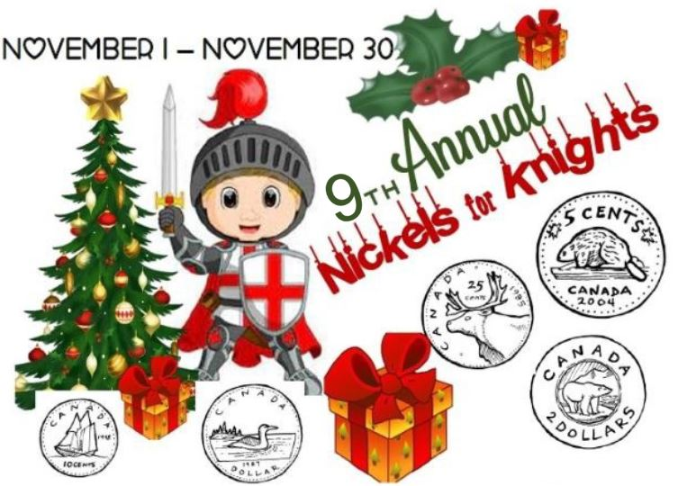

Airdrie Food Bank Drive
November is Heloise Lorimer’s month to support the Airdrie Food Bank! This year, we will be feeding our Knights bellies again with non-perishable food items. The Airdrie Food Bank has shared that their client use is up, indicating a real need for some Airdrie and area families. This food drive initiative enables our school to meet the RVS/School goals, while at the same time assisting those local and area families in need.
There are 2 ways you can donate to our initiative this year:
1. Make a monetary donation to SchoolCash Online.
2. Send non-perishable items with your child. To find out what items are needed most, please go to: https://www.airdriefoodbank.com/whatsneededmost
We thank you in advance for helping us to support our Community Food Bank!

