
KNIGHTS NEWS – May 30, 2025

As we approach the final stretch of the school year, we want to take a moment to thank you for your continued partnership and support throughout this academic journey. June is always a busy and exciting month as we celebrate student achievements, wrap up projects, and prepare for a well-earned summer break. As always, we encourage students to finish strong, stay engaged, and support one another as the year concludes.

Dates To Remember
Thursday, June 5 – Spring Fling Dance
Tuesday, June 10 – Spirit Day – Beach Day
Wednesday, June 11 – Family/Volunteer Appreciation
Wednesday, June 11 – School Council
Thursday, June 12 – Indigenous Peoples Day Celebration
Thursday, June 19 – Kindergarten Knighting Ceremonies (AM – 9:15 am and PM - 1:15 pm)
Friday, June 20 – Last Day of Kindergarten (PM)
Tuesday, June 24 – Festival of Knights Field Day
Wednesday, June 25 – Last Day of School

We will be sending out our final newsletter as the last day approaches with information for the 2025-2026 school year. We do have administration announcements for next year:

Principal: Ms. LaToya Bartlett
Assistant Principal: Ms. Kathryn Smith
Assistant Principal: Mr. Vladimir Stelkic


Spring Fling School Dance

When: Thursday, June 5th 5:00pm-7:00pm
Where: Heloise Lorimer Gym
Who: All HLS families are invited to attend
Cost: $5/Per Family Payable through School Cash Only

Please Remember: All students need to be accompanied by an adult to attend the dance.

*Cash only for Concession Items

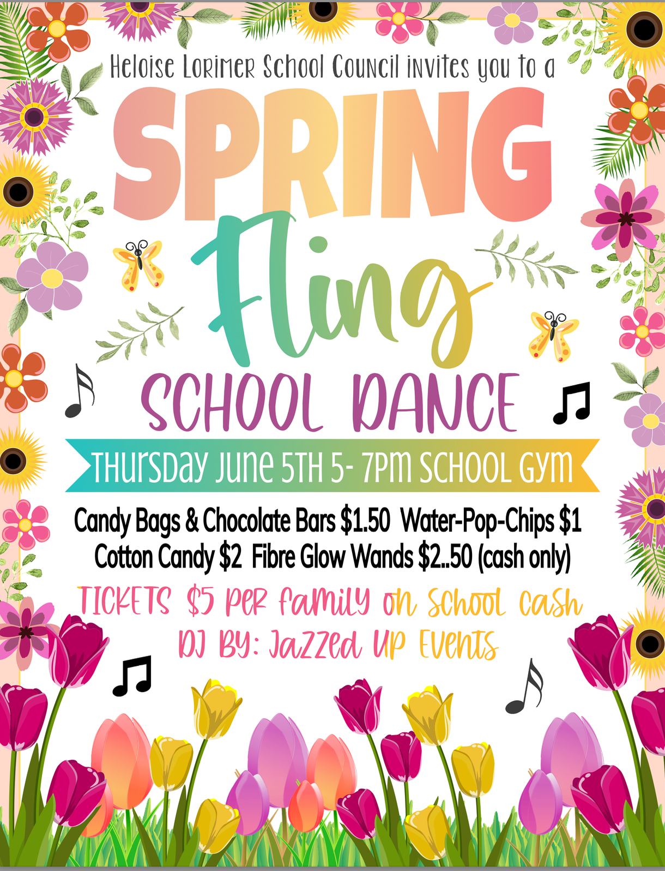

Family/Volunteer Appreciation
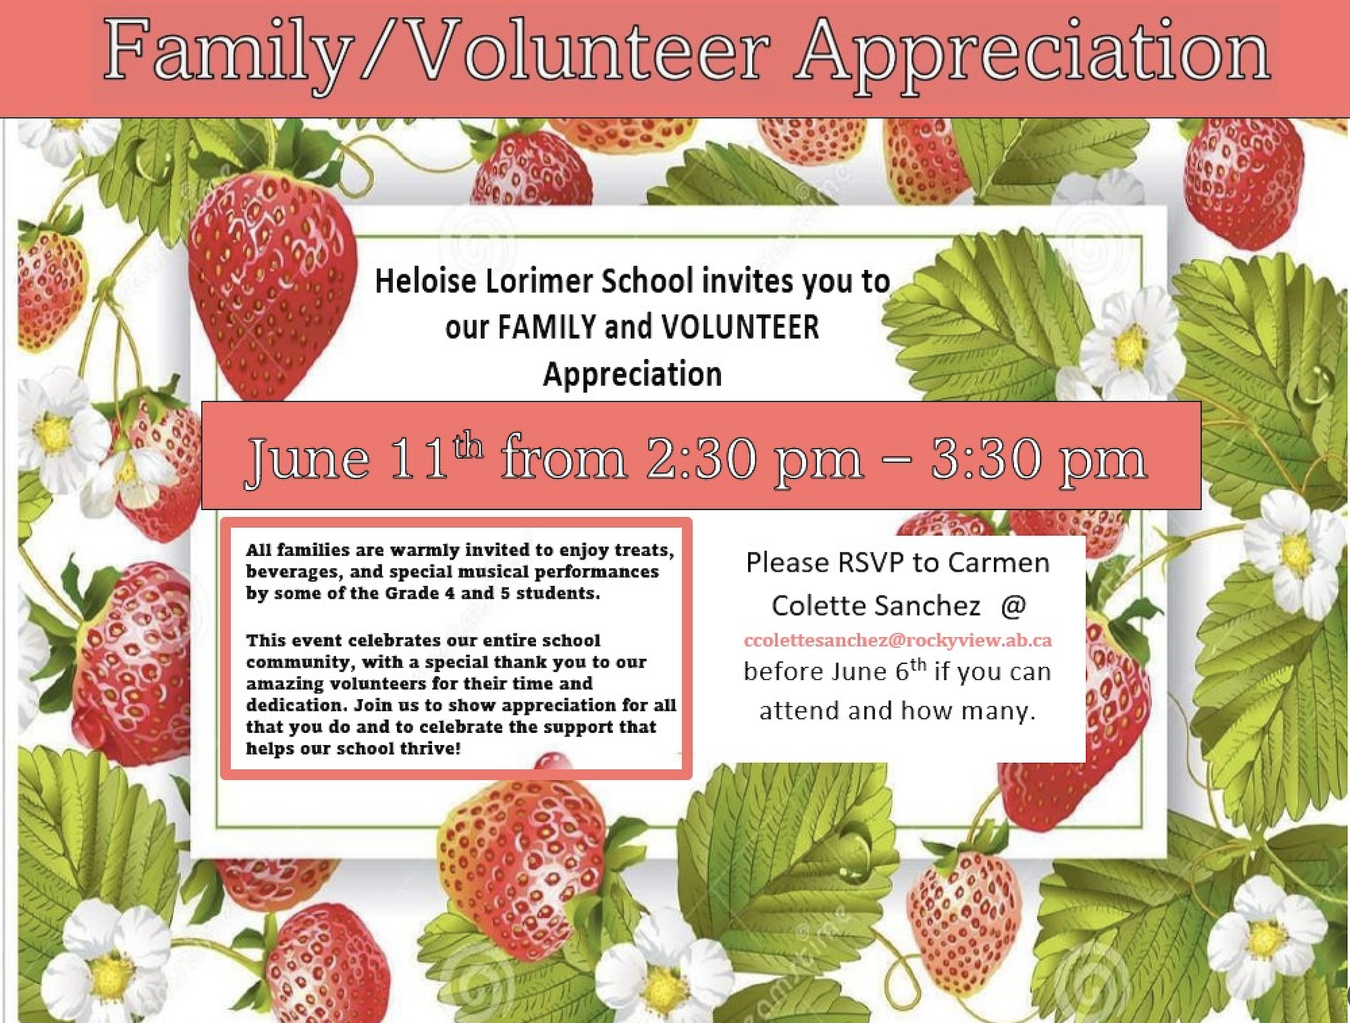
OurSCHOOL Survey
As part of our school planning process, students have participated in an online school perception survey for students called the OurSCHOOL Student Survey. Based on how students respond to the questions in the survey; we can make changes to improve their experiences at school and engage their participation in school activities
Students are given a random username and password to access and complete the survey online. Students’ names cannot be linked to their responses which allows it to be completely anonymous. Results will show all student scores combined – it is not possible to single out individual students in the results. The OurSCHOOL Survey is accessible from any web‐enabled device, for example, computers and tablets.

Some of the questions may seem unrelated to school, but all questions included in the OurSCHOOL survey can help tell us about the students, their health, and school-related outcomes. There will also be some questions that seem personal in nature, such as what language is spoken at home. We ask these questions in the survey to help tell us more about you and to make sure that all our school planning decisions work equally well for all students.

The survey is designed to be completed in approximately 45 minutes. The survey measures include such topics as emotional and social well-being, physical health, and behaviours and attitudes linked to student success. The survey also allows participants to give their thoughts and feedback in open-ended question responses.

Our next step is to collect information from the OurSCHOOL Parent Survey. The survey will run from May 12th to June 6th. This survey will be accessible for all parents from Kindergarten to Grade 12. Please stay tuned for more details.

National Indigenous People’s Day (June 12)
On June 12, we are recognizing and celebrating the history, heritage, resilience and diversity of First Nations, Inuit and Métis across Canada. HLS will be recognizing National Indigenous People’s Day with a day of activities including Dancing, Tipi Building, Drumming, Games of the North, Creating Ribbon Skirts and Bannock Making.

Assessment at RVS: Numeracy and Literacy Interventions

Rocky View Schools is sharing a series of articles on the division website regarding assessments: the process of gathering data about student learning. This information is intended to help provide greater insight into why and when assessments are done and encourage ongoing communication between teachers and families to support student success.

Read the second article in our series this month, covering numeracy and literacy interventions at RVS. Our earlier article, Understanding Provincial and Divisional Assessments, is also available on our website.

Register Now to Save on Transportation Fees
Rocky View Schools (RVS) has opened transportation registration for the 2025/26 school year through SchoolEngage. Parents/guardians are encouraged to register by June 30 to receive a $40 discount or by Aug. 1 to ensure bus service for the first day of school.

In response to rising costs, transportation fees have increased for the coming school year. A list of fees is available on the RVS website. Families are encouraged to take advantage of the early registration discount to offset some of the transportation cost. Eligible families may also apply to have their transportation fees waived by completing a Transportation Fee Waiver.

The June 30 early registration discount of $40 is extended to each of the first two Kindergarten – Grade 12 students in a family, with additional students receiving $20 off if registering early. A minimum payment of 50 per cent is due at registration. Bus service may be cancelled up until Oct. 31 to receive a full refund for all fees paid.

Families are urged to register as soon as possible for transportation to ensure a smooth start to the fall. To guarantee service for the first day of school, registration must be received before Aug. 1. Students registered after this deadline may experience delays of two to three weeks before they can ride the bus.

A step-by-step guide to registration, fee information and more is available on the Transportation section of the RVS website.

Pre-Pak Meat Fundraiser
It’s the perfect time to stock your freezer for summer camping trips and BBQ season! There are a variety of different options including:
Steaks
Burgers
Shrimp
Chicken
Bacon
By ordering, you’re not just filling your freezer — you're also supporting Heloise Lorimer’s Festival of Knights Field Day!
Head to SchoolCash Online to place your order today and help make this event unforgettable for our students!
Ordering will be open until Monday, June 2, 2025. Orders can only be placed through School Cash Online. Pick up will be at Heloise Lorimer School on Monday, June 16th.
Thank you for your support!

Student Belongings – Lost and Found
As stated in our school handbook which is located on our website:
The care of personal property is each student’s responsibility. The school cannot assume responsibility for missing items. All articles of clothing and school supplies should be marked with the student’s name. Students are strongly discouraged from bringing any valuable items to school. The school is not responsible for the loss, damage of or replacement of personal items.
Check out our Lost and Found – located in our main foyer

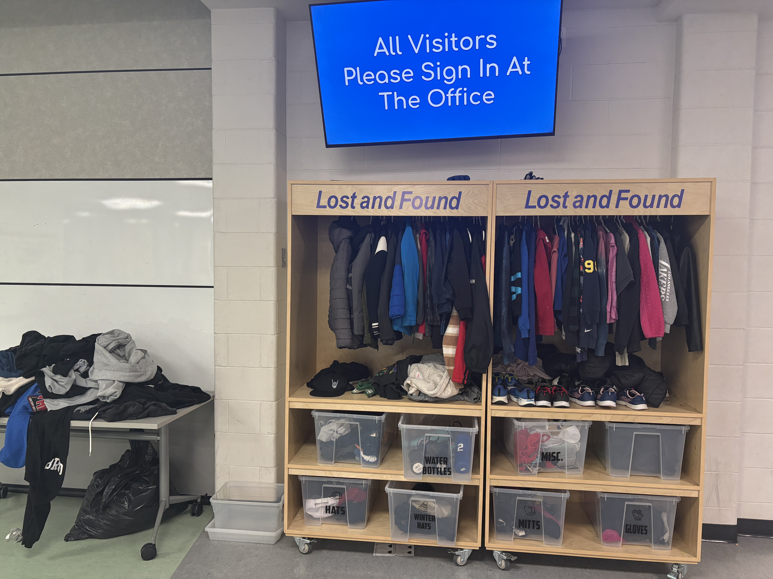

Healthy Hunger Fun Lunches
Our school has a program with Healthy Hunger known as "Fun Lunch". We partner with various vendors every week and families can purchase fun lunches on a weekly basis. The lunches are delivered to the school and distributed to the students. Classes are loaded for the 2024-2025 school year.
Please Note: The deadline to order is 5 days before the lunch date, so typically our order deadline is Saturday at midnight! If your student is absent on the day of fun lunch, please call the office by noon, if you will be coming to pick up the lunch OR if you would like the lunch kept for when your student returns. If your child is not at school, and we do not hear from the family, the lunch WILL NOT be kept for the student. Pickups will be available at the office after 1:00 pm.

Did you know that fun lunch is a fundraising program? A portion of the proceeds from each lunch ordered go back to the school. We use these funds to support our school community, such as field trips, school dances and events, curricular projects, active living week and more!

We are always looking for volunteers to help distribute lunches on Thursdays. Reach out to Karen at karenlc@live.ca for help setting up your account or to volunteer.

Upcoming Lunches:

Thursday, June 5 – State and Main
Thursday, June 12 – Boston Pizza

School Council
School Councils play an invaluable role in providing parents with opportunities for meaningful involvement in their children’s school. School Councils encourage a strong partnership between the school and the family and help parents become actively involved in the education of their children. School Councils have implemented strategies, practices and activities which have created the conditions for parents to engage in their child’s education and have reduced barriers for parents who find involvement more challenging.
Please join our school council. It is an enjoyable time to hear what has been happening in the school as well as what we can look forward to. It is a chance to hear from other parents, administration, teachers, and our trustee and to ask questions. Our meeting dates are as follows:
June 11/25 @ 6:30 pm
Our last school council meeting of the year is scheduled for Wednesday, June 11th at 6:30 pm. We will be meeting in person, at the school, in our staffroom beginning at 6:30 pm.

Sky High Twirlers
Did your child(ren) enjoy baton? If you're looking for more opportunities for them to try it out, visit the website of Airdrie's Sky High Twirlers for more information: https://www.skyhightwirlers.com/

Sincerely,
Mrs. Terry Lewis and Ms. Kathryn Smith
Heloise Lorimer School Administration Team
